Project Name:

**Weather Report Forecasting Analysis and Visualisation**

Initiator:

**HiCounselor and Aditya Sharma**

Group Name:

**Data Squad**

**Group Members:**

* Ifeoluwa Ogunmiluyi
* David Awolola
* Diekolola Babatunde
* Idowu Lawal
* Kayode Faremi

This report contains solutions to all listed requirements in the project named above:

**Question 1**: Give the count of the minimum number of days for the time when temperature reduced

**Solution**:



**Question 2**: Find the temperature as Cold / hot by using the case and avg of values of the given data set

**Solution**:

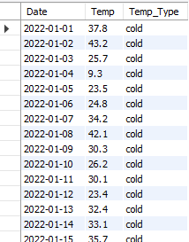

**Question 3**: Can you check for all 4 consecutive days when the temperature was below 30 Fahrenheit

**Solution**:

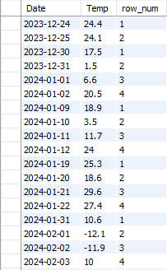

**Question 4**: Can you find the maximum number of days for which temperature dropped

**Solution**:



**Question 5**: Can you find the average of average humidity from the dataset

(NOTE: should contain the following clauses: group by, order by, date )

**Solution**:

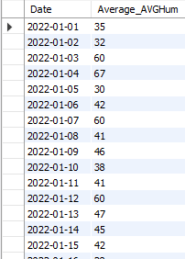

**Question 6**: Use the GROUP BY clause on the Date column and make a query to fetch details for average windspeed

**Solution**:

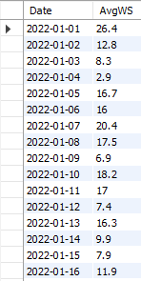

**Question 7**: Please add the data in the dataset for 2034 and 2035 as well as forecast predictions for these years

**Solution**: Unable to present result as there were no 2034 and 2035 data.

**Question 8**: If the maximum gust speed increases from 55mph, fetch the details for the next 4 days

**Solution**: We are unable to get the details of the next four days, however, we got the details of the days with over 55mph maximum gust speed.

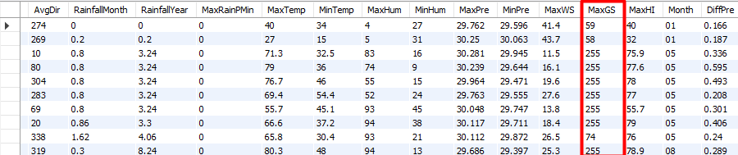

**Question 9**: Find the number of days when the temperature went below 0 degrees Celsius

**Solution**:



**Question 10**: Create another table with a “Foreign key” relation with the existing given data set.

**Solution**:

